Steps：

1. gcc -pthread Fibonacci.c -o Fibonacci.o

2. ./ Fibonacci.o

3. enter a number

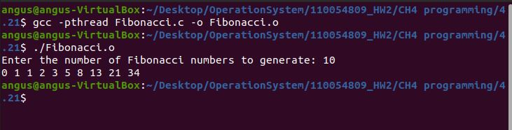

Source code：

#include<stdio.h>

#include<stdlib.h>

#include<pthread.h>

int fibAry[100000]; //shared array

void *fibonacci(void *input) {

int f1 = 0, f2 =1, num;

for (int i = 0; i < *(int *) input; i++) {

if (i <= 1) {

num = i;

} else {

num = f1 + f2;

f1 = f2;

f2 = num;

}

fibAry[i] = num;

}

pthread_exit(0);

}

int main() {

printf("Enter the number of Fibonacci numbers to generate: ");

int input;

scanf("%d", &input);

pthread_t thread;

pthread_create(&thread, NULL, fibonacci, (void *) &input);

pthread_join(thread, NULL);

for (int i = 0; i < input; i++) {

printf("%d ", fibAry[i]);

}

printf("\n");

return 0;

}